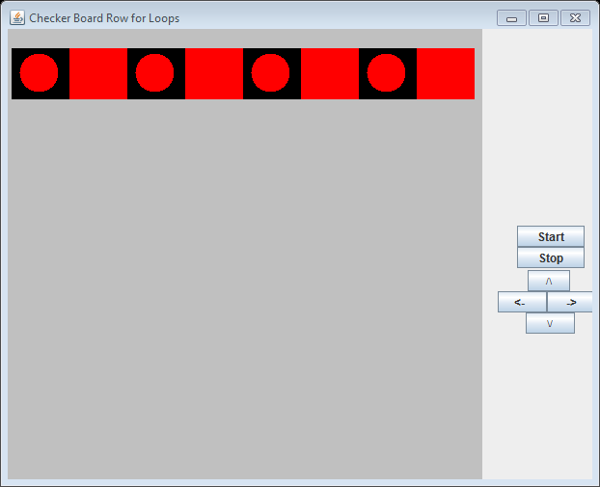

**Figure 5.7 The output from the application CheckerBoardRow.**